**Our Cause Defines Us**  
At the YMCA, we believe that lasting personal and social change comes about when we all work together. That’s why strengthening community is our cause. Every day, we work side-by-side with our neighbors to make sure everyone—regardless of age, income, or background—has the opportunity to learn, grow, and thrive.

**The Y:**

* Is a nonprofit like no other, with a presence in over 10,000 neighborhoods across the country, delivering real and lasting change.
* Is community-centered. For over 175 years, we've been listening and responding to local needs.
* Brings people together. We connect individuals of all ages and backgrounds to bridge gaps and foster understanding.
* Nurtures potential. We believe everyone should have the opportunity to reach their full potential.
* Has a local presence and global reach. We mobilize communities to create meaningful change.

**Our mission** is to put Christian principles into practice through programs that build a healthy spirit, mind, and body for all. Our impact is seen when individuals make healthy choices, mentors inspire youth, and communities unite for the common good.

**YMCA Core Values**

We encourage all coaches and parents to incorporate the YMCA’s core values into every practice, game, and interaction. Our goal goes beyond teaching sports—we’re shaping good people.

* **Caring:** Care for others without limitations. Treat all players with kindness and fairness.
* **Honesty:** Be truthful with yourself and others. Model integrity, even when it's difficult.
* **Respect:** Treat everyone—players, opponents, officials, and parents—with dignity and humility.
* **Responsibility:** Be dependable. Know your sport, be prepared, and lead with integrity.

**Our Areas of Focus**

The YMCA is a cause-driven organization focused on:

* **Youth Development:** Helping young people realize their potential in safe, enriching environments.
* **Healthy Living:** Supporting wellness in spirit, mind, and body.
* **Social Responsibility:** Encouraging community involvement and giving back to others.

**Opportunities for All**

The Y is for everyone. Our programs help children discover their potential, encourage families to grow together, and empower individuals to live healthier lives.

**YMCA Youth Sports Philosophy**

Our youth sports philosophy emphasizes Christian values, skill development, fitness, fun, and friendly competition. Every child should have the opportunity to participate. Families are encouraged to be involved.

**Program Objectives:**

* Build self-confidence and self-respect.
* Foster respect for others, including opponents, teammates, and officials.
* Emphasize teamwork over winning.
* Improve physical fitness and skill development.
* Create positive, shared experiences.
* Recognize sportsmanship over individual achievement.
* Encourage awareness and value of others.
* Support social skill development.
* Provide personal growth through value-based learning.

**Coach Expectations**

As a YMCA coach, you are a role model. Your behavior and attitude will influence your players both on and off the field. Our goal is to help youth grow in fitness, character, sportsmanship, and self-worth—not to create professional athletes.

**Coach Responsibilities:**

* Communicate regularly with YMCA staff.
* Encourage personal growth and participation for every child.
* Improve players' skills and love for the game.
* Treat all players fairly and respectfully.
* Ensure every player gets at least 50% playing time.
* Rotate players through different positions.
* Be on time, prepared, and professional.
* Teach grace in winning and losing.
* Reinforce positive behavior and team development.
* Provide a fun, safe, and encouraging environment.
* Communicate effectively with parents.
* Maintain a thorough understanding of the sport and its rules.
* Promote a no-tolerance policy for bullying.
* Lead by example at all times.

**Keys to Being a Great Coach**

* **Have Fun:** Keep smiles front and center. Happy players are successful players.
* **Be a Role Model:** Players mirror your words, actions, and attitude.
* **Stay Positive:** Focus on strengths and turn challenges into learning moments.
* **Be a Friend:** Listen to and encourage every child.
* **Everyone Plays:** All players should participate in at least half of every game.

**The Coach’s Role in YMCA Youth Sports**

* **Teach Skills & Tactics:** Help players develop their physical and strategic abilities at their own pace.
* **Promote Rules & Sportsmanship:** Reinforce fairness, respect, and positive behavior.
* **Encourage Lifelong Fitness:** Make physical activity fun and engaging.
* **Build Character:** Model and teach the Y’s core values.
* **Ensure Safety:** Supervise all activities and maintain safe play environments.
* **Support Self-Worth:** Help each child recognize their value.
* **Make it Fun:** Create memorable, enjoyable learning experiences.

**Practice Plan & Preparation**

Practice is essential to player development, team bonding, and overall success. Coaches should come prepared with:

* Knowledge of rules
* Necessary equipment
* A clear plan for practice components
* Any relevant news or updates
* A positive attitude!

**Every practice should include:**

* Stretching (before and after)
* Rotating stations to keep engagement high
* Fun games or scrimmages
* Scheduled breaks
* Positive reinforcement

**Knowledge of the Game**

You don’t need to be a pro, but a solid understanding of your sport’s rules is essential. Rulebooks will be provided. New coaches are encouraged to connect with experienced coaches for mentorship. Let us know if you’d like an introduction.

**Post-Coaches Meeting Tasks:**

* Contact all team members' parents before first practice.
* Clarify practice dates/times, game schedules, and expectations.
* Recruit assistant coaches or team parents (must meet YMCA volunteer standards).

**Reporting Procedures**

**Complaints**

* Report all complaints to the site supervisor before or after the game.
* If not resolved on-site, notify a YMCA Director.
* Parents, coaches, and staff will be informed of any resolutions.

**Suggestions**

* Suggestions are welcomed and reviewed.
* Share them verbally or in writing with a site supervisor or Sports Director.

**Inappropriate Behavior**

**Players:**

* Cursing, poor sportsmanship, threats, or violence will not be tolerated. These may result in suspension.

**Coaches/Parents:**

* Obnoxious behavior, harassment of officials, or unsportsmanlike conduct will result in a warning or immediate removal depending on severity.

**Officials**

* Have full authority from start to finish.
* Can caution or eject players, coaches, or fans.
* May terminate games if necessary.
* All decisions are final. Abuse toward officials will not be tolerated.

Please address concerns with the Site Supervisor or the YMCA Sports Director.

**PARENT VOLUNTEERS**

Participation of volunteers is integral to the success of our tackle football program. We encourage parents to join us and be part of this enriching experience with their children. No prior experience is necessary; this program is a learning opportunity for everyone. Volunteers are needed for the following roles:

**Timekeeper**

* **Game Clock:** Start, stop, and reset the clock as per referee signals, including for touchdowns, timeouts, and penalties.
* **Play Clock:** Manage the timing between plays to ensure the game flows smoothly.
* **Communication:** Work closely with on-field officials to accurately manage game timing.
* **Knowledge of Rules:** Understand football rules related to game timing for fair and accurate clock operation.
* **Pressure Handling:** Perform duties effectively during crucial game moments.

**Referees**

* **Enforce Rules:** Interpret and apply football laws, make decisions on infractions, offsides, and penalties.
* **Game Management:** Start, stop, and regulate play, manage player conduct, and resolve disputes.
* **Sportsmanship:** Maintain fair play and impose penalties for misconduct.
* **Effective Communication:** Clearly explain decisions and coordinate with players, coaches, and fellow officials.
* **Physical and Mental Readiness:** Maintain pace, make quick decisions under pressure, and ensure consistent judgment.

**Chain Gang**

* **Rod Men (Rear and Forward):** Manage markers for downs and distances, indicating the start and necessary distance for first downs.
* **Box man:** Display current down using a down indicator pole, updating after each play.

**FACILITY GUIDELINES**

* Dispose of trash properly.
* Respect YMCA property.
* Stay off the field between games.
* Drive slowly and park in designated areas only.
* Children must be supervised at all times.
* Pets must be leashed; disruptive pets will be asked to leave.
* Parents/guardians must be present unless prior arrangements have been made with staff.

**LOST & FOUND**

Any items left behind at practices or games will be turned in to the **front desk at the Oahe Family YMCA**.

We highly recommend labeling your child’s belongings, especially water bottles, gear bags, and equipment.

**INCLEMENT WEATHER PROCEDURE**

If bad weather or unsafe conditions occur:

1. YMCA staff will notify parents and coaches **at least one hour before game time**.
2. Coaches are responsible for canceling practices and informing their teams.
3. On-site cancellations will be announced by the Site Coordinator.

While we do our best to reschedule games, it may not always be possible due to field availability and time constraints.

**SAFETY & SUPPORT**

**First Aid**

YMCA staff are **CPR-certified** and trained to handle minor injuries and emergencies. First aid supplies (bandages, ice packs, AED) are available at all times.

**If a player is injured:**

* Notify a staff member immediately.
* Do not move the player if the injury appears serious.
* YMCA staff will assess and respond or call emergency services as needed.
* An incident report will be completed for any injury requiring more than basic first aid.

Encourage players to report any injuries—even small ones—right away.

**In the Case of a Player Emergency**

* Parents/guardians will be notified **immediately by on-site staff** either **in person or by phone**.
* If a parent or guardian **cannot be reached**, the **emergency contacts listed on the child’s registration form** will be contacted without delay.

**Officials**

Officials have full authority during games. They may:

* Warn or eject for unsportsmanlike behavior
* End a game due to safety or conduct concerns

**Abuse of officials is not tolerated.** All concerns must go through proper YMCA channels.

**YMCA Staff**

YMCA staff will be on-site during all games and practices. For questions or concerns, please speak with the site supervisor or Program Director **before or after** a game—**never during**.

**Practice & Games**

The program starts with **four weeks of practice**, followed by scheduled recreational games at the Oahe Softball Complex (S Buchannan Ave.), fields A, B, C, and D. The season schedule will indicated when and what field teams will be.

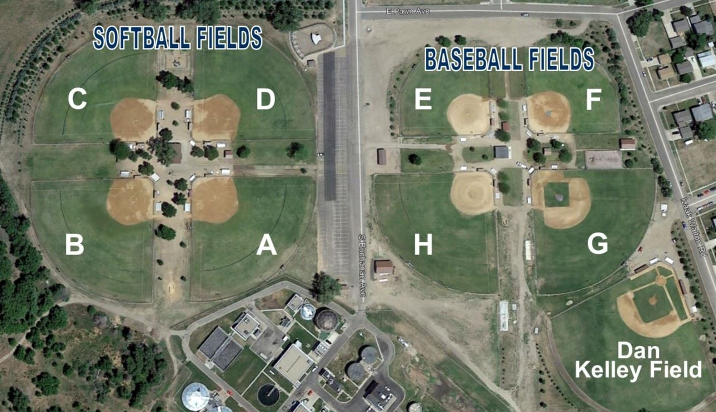

Games will take place at locations listed on your team’s schedule. The season concludes with **Friday Night Lights**, an evening of games at **Hollister Field**.

**Friday Night Lights**

Friday Night Lights is the end-of-season celebration hosted at Hollister Field. We transform Hollister Field into two smaller football fields, hosting simultaneous games for all grades. Each game will run for one hour, so we encourage teams to arrive early and be prepared to play.

Please remember that teams are responsible for providing referees, timers, and chain gangs, just as they do at the softball fields.

Bleachers will be available for parents, friends, and family to cheer on the teams, creating a lively atmosphere for everyone involved.

As a reminder, we ask that all attendees help keep the field clean. Coaches should ensure their teams dispose of trash before leaving, as we want to maintain a tidy environment for future events.

**Practice Equipment**Each team will be provided with the following equipment for practices:

* A bag of footballs
* Cones
* Tackling dummies
* Blocking shields
* Jerseys – Distributed to coaches at their first practice. Jerseys will be assigned to players for the season and must be returned after Friday Night Lights.

All equipment should be handled with care and respect when not in use. During practice, equipment should remain on the field, and at the end of the evening, it must be returned to the Y van.

**Game Equipment**The following equipment will be provided for each game:

* A bag of footballs
* Referee vest and flags
* Yard line markers
* Down box and chain set

After each game, all equipment should be collected and returned to the Y van before leaving for the evening.

**Inclement Weather Procedure**

In case of bad weather or unsafe conditions:

1. YMCA staff will notify coaches/parents at least one hour before game time.
2. Coaches are responsible for cancelling practices and notifying players.
3. The Site Coordinator will announce on-site cancellations.

While we strive to reschedule canceled games, it may not always be possible.

**Emergency Action Plan (EAP) – Oahe Family YMCA Tackle Football Program**

**Program Information**

* **Program: YMCA Tackle Football**
* **Location: Oahe Softball Complex**
* **Season: Sept 4 – Oct 24, 2025, Mondays and Thursdays**

**Purpose**

**The purpose of this Emergency Action Plan (EAP) is to provide coaches, staff, and volunteers with clear procedures to follow in the event of a medical emergency, severe weather, or other crisis during practices and games.**

**Roles & Responsibilities**

* **Coach (or Lead Staff on Site):**
  + **Takes charge of the emergency situation.**
  + **Assigns roles to assistant coaches/volunteers.**
  + **Ensures athletes are kept safe and calm.**
* **Lead Staff / Coach / Volunteer:**
  + **Calls 911 if necessary.**
  + **Provides first aid until emergency personnel arrive.**
  + **Meets emergency responders and directs them to the scene.**
* **Lead Staff / Parent / Volunteer:**
  + **Stays with non-injured players.**
  + **Contacts the injured athlete’s parent/guardian.**

**Emergency Communication**

* **Emergency Number: 911**
* **Nearest Hospital: Avera St. Mary’s Hospital**
* **Non-Emergency Police: (605) 773-7410**
* **Field/Facility Address (for 911 call):**
  + **800 S Buchanan**

**Always give:**

1. **Your name and role.**
2. **Nature of the emergency (injury, weather, etc.).**
3. **Exact location and directions.**
4. **Condition of the athlete(s).**
5. **Actions being taken.**

**Medical Emergencies**

1. **Severe Injury/Illness (unconsciousness, breathing issues, neck/spine injury, severe bleeding, suspected concussion, broken bone):**
   * **Call 911 immediately.**
   * **Do not move the athlete unless in immediate danger.**
   * **Provide first aid/CPR if trained.**
   * **Assign someone to meet EMS at the field entrance.**
2. **Concussions:**
   * **Remove athlete from play immediately.**
   * **Do not allow return until cleared by a medical professional.**
3. **Minor Injuries:**
   * **Provide first aid (bandages, ice, etc.).**
   * **Notify parent/guardian after practice/game.**

**Severe Weather**

* **Lightning/Thunder:**
  + **Follow the 30/30 Rule (if lightning is seen and thunder is heard within 30 seconds, evacuate immediately).**
  + **Suspend all activity for 30 minutes after last lightning/thunder.**
  + **Move athletes to cars, buses, or indoor shelter (not dugouts or under trees).**
* **Tornado/High Winds:**
  + **Move indoors if possible.**
  + **If no shelter, instruct players to lie flat in a ditch or low ground area.**
* **Extreme Heat:**
  + **Monitor heat index.**
  + **Provide frequent water breaks.**
  + **Modify practice length or intensity as needed.**

**Other Emergencies**

* **Missing Child:**
  + **Alert staff and parents immediately.**
  + **Call 911 if child is not located promptly.**
* **Fire/Explosion Nearby:**
  + **Evacuate to designated safe zone away from the hazard.**
  + **Call 911.**
* **Intruder/Violent Situation:**
  + **Move athletes to safety.**
  + **Call 911.**
  + **Do not engage unless necessary for protection.**

**Emergency Equipment**

**Each team should have:**

* **Ice Packs**
* **Emergency Contact List for all athletes**
* **Cell phone for emergency use**
* **First Aid Kit – located in the YMCA van on site**
* **AED – located in the YMCA van on site**

**Post-Emergency Procedures**

* **Staff will file an Incident Report with the YMCA office within 24 hours.**
* **Debrief with staff, coaches, and athletes as needed.**
* **Staff will provide support/resources for athletes and families affected.**

**Would you also like me to create a short “sideline version” (like a half-page quick reference) that your coaches can keep in their binders or pockets during games? That way they don’t have to flip through the full plan.**